- Debugging Teevra USING Eclipse
- Start the application and tell the JVM that it will be debugged remotely
- Configure your IDE on your desktop to be able to debug that remote application
  - Starting the Application with Remote Debugging Enabled

java -Xdebug -Xrunjdwp:transport=dt_socket,address=8998,server=y -jar myapp.jar

The above command says: start myapp.jar + start a server socket at port 8998 and publish the debugging messages using the Java Debug Wire Protocol (jdwp) there.

(debugfusion.bat file is modified for this purpose, start the server using this startup script)

Other than address, server, and transport there are other sub options available for -Xrunjdwp option -- for example: suspend.
  - Configuring Eclipse to Debug a Remotely Running Application
- Start Eclipse
- Go to Run -> Debug Configurations
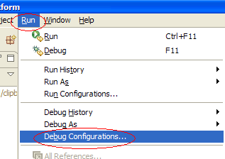
- Create a new Remote Java Application configuration
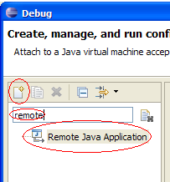
- Configure the remote application's details
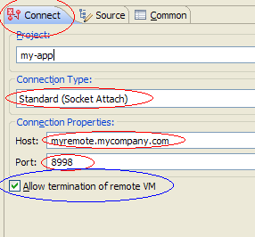
- If you would like to have this launch configuration in your favorites menu 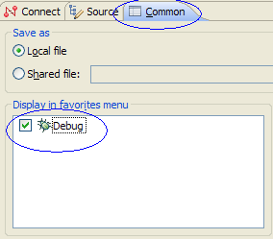

- ATTACHING PROFILER TO TEEVRA ( JPROFILER )
- Add org.osgi.framework.bootdelegation=com.jprofiler.agent property in the fusion.properties file in the launcher module. This is required so all the JProfiler related classes are available to all the modules in the server.
- Start Teevra with following command line options.

-agentlib:jprofilerti=port=<Port > "-Xbootclasspath/a:<JProfiler Home>\bin\agent.jar"
- Start the Teevra server.
- Create a new Session in JProfiler using Remote Integration Wizard.

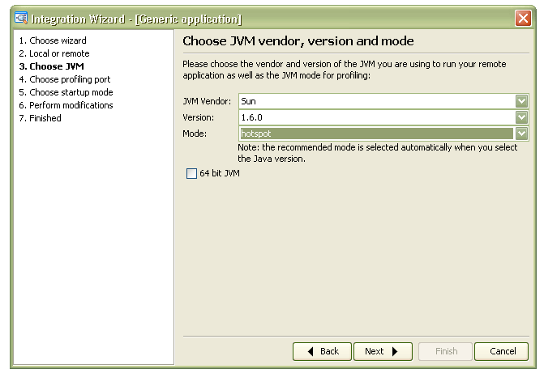

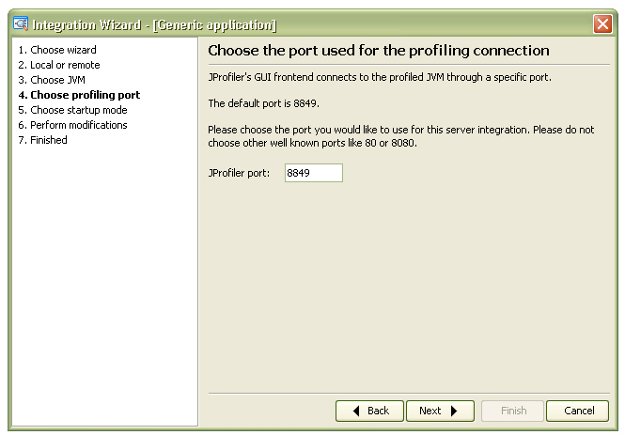

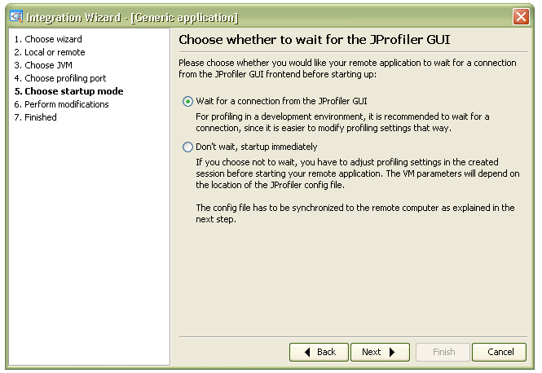

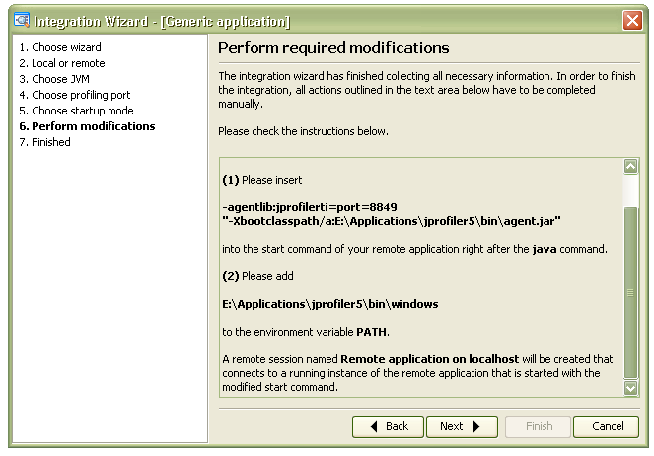

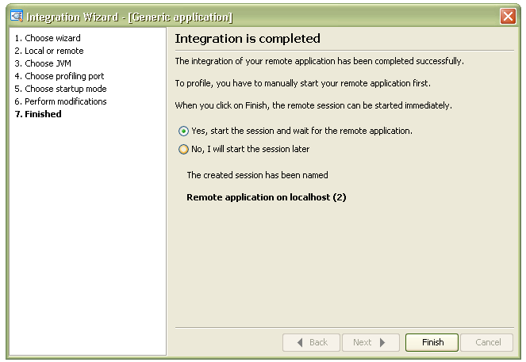

- Start the profiler.

